**NOTICE!  
ASH TOWNSHIP FIRE DEPARTMENT FIRE TRUCK BIDS  
BIDDING WILL END AUGUST 19th AT 4:00PMBids starting at $20,000**

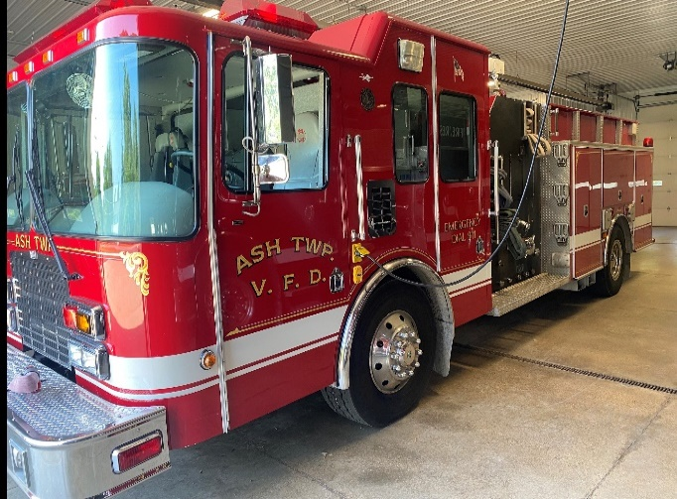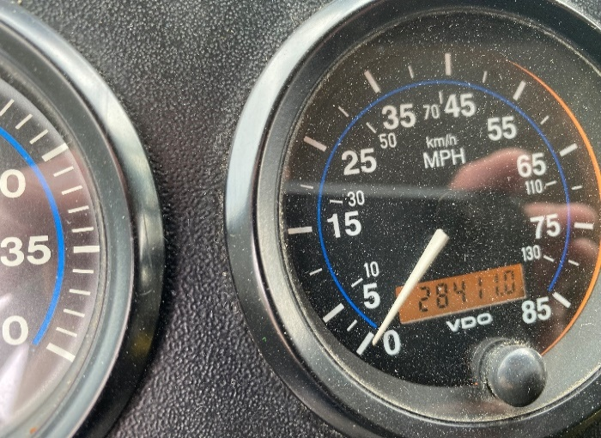

**2001 Four Guys/HME Custom Pumper Fully Operational All Stainless-Steel Body  
1677 Ready Road, Carleton, MI 48117**

***General***

4 Man Cab w/3 SCBA seats  
Cummings 6CYL 350HP with Engine Brake  
Allison MD3066 (P) 5 Speed Auto Transmission  
Air Conditioning  
Aluminum Hose Bed Cover, Hydraulic Ladder Rack  
35’ Ground Ladder, 14’ Roof Ladder, 10’ Attic Ladder

***Pump & Tank***

Hale QMAX Series 1500 GPM – Pump test up to date  
1,000 Gallon UPF Poly-Tank, Deck Gun

***Generator & Lighting***

10,000 KW Harrison Hydraulic Generator  
(2) 1500-Watt Telescoping Lights  
(4) Whelen 6E Scene Lights

***Dimensions***

28,411 miles - 2255 Engine HRS, Wheelbase 204”   
Overall Length 384” – 32’ / Overall Width 98” / Overall Height 118”

**Please send sealed bids no later than August 19th to: Ash Township – Fire Department Bid  
P.O. Box 387, Carleton, MI 48117 | For more information, call (734) 654-6992, ext. 0 or via email at** [rschock@ashtownship.org](mailto:rschock@ashtownship.org)**.**  
***Visit us at our Ash Township Facebook page for more pictures!***



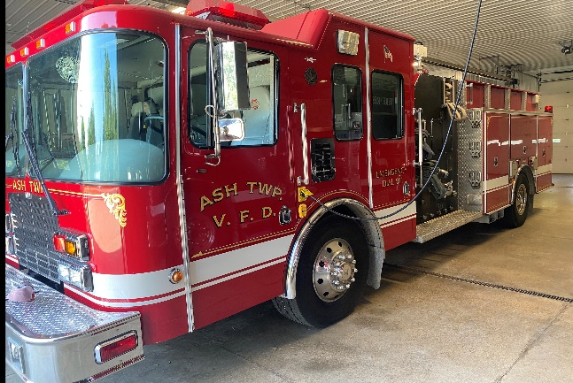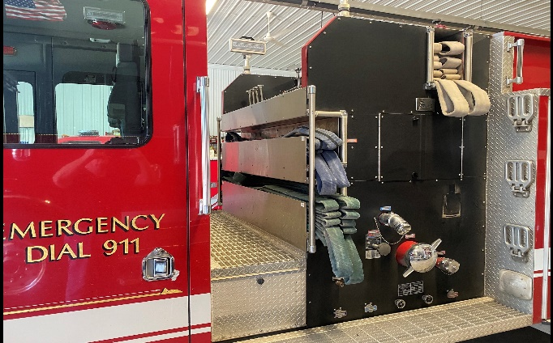

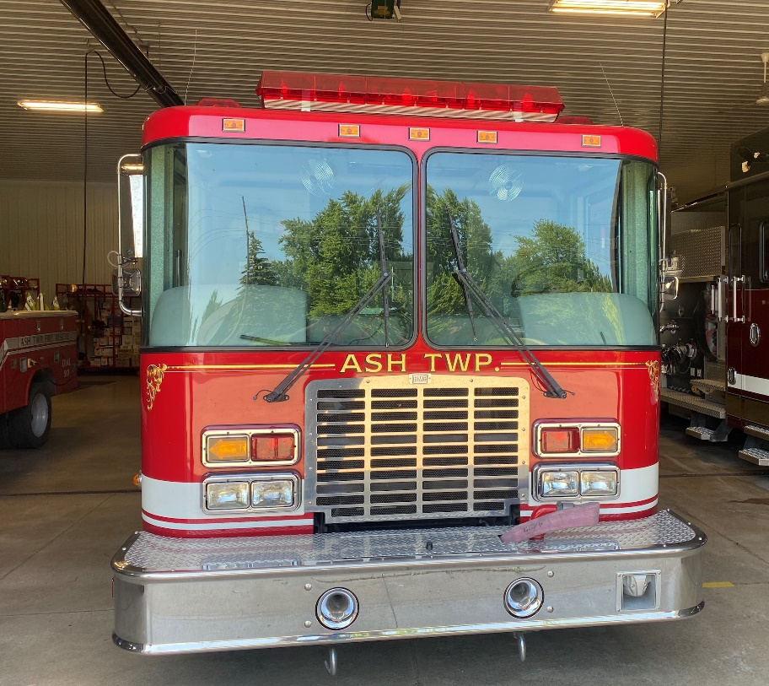

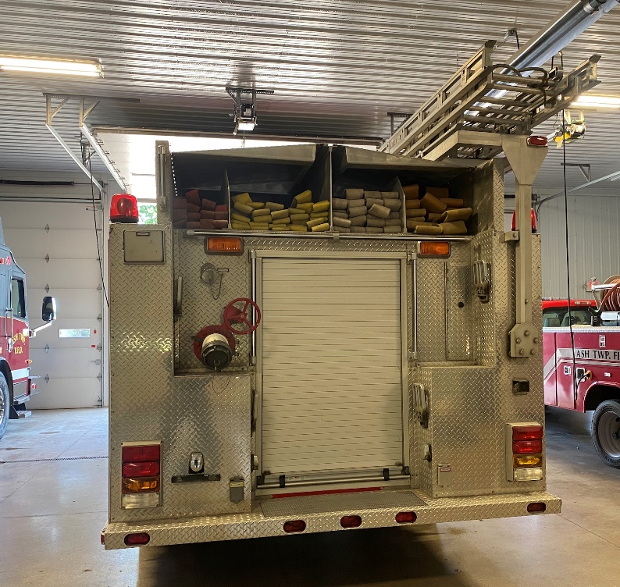

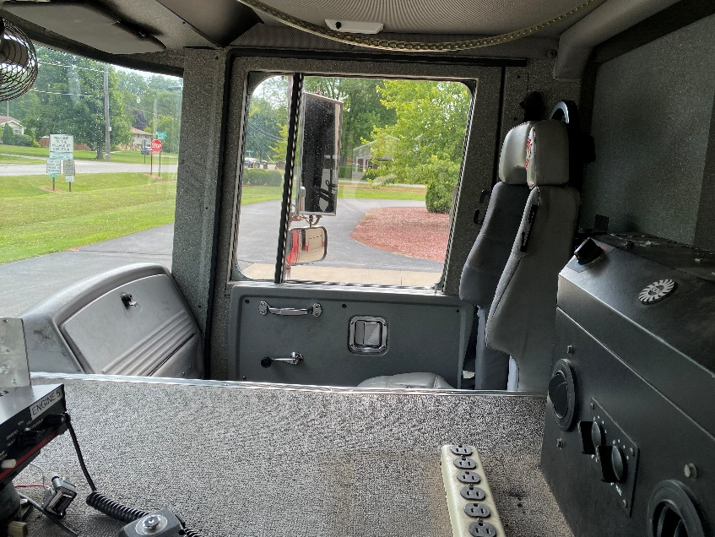

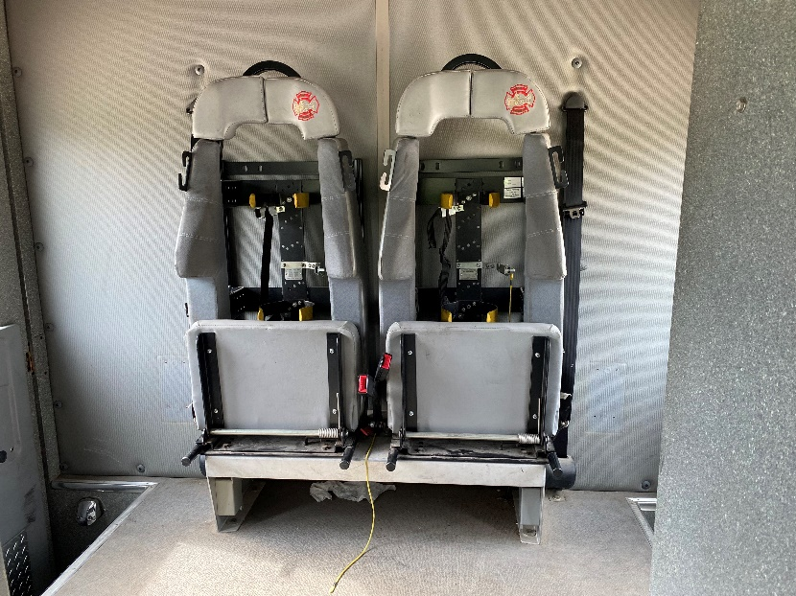

**ASH TOWNSHIP FIRE DEPT TRUCK  
2001 Four Guys/HME Custom Pumper Fully Operational All Stainless-Steel Body  
28,411 miles - 4 Man Cab w/ 3SCBA Seats - Overall Length 384” - 32’   
Overall Width 98” - Overall Height 118”**

BIDS WILL BE ACCEPTED FROM 8:00AM – 4:00PM,   
MONDAY – THURSDAY THROUGH AUGUST 19, 2025 BY 4:00PM

***ALL SEALED BIDS MUST BE DROPPED OFF OR MAILED TO:***

ASH TOWNSHIP-FIRE TRUCK BID  
1677 READY ROAD, P.O. BOX 387  
CARLETON, MI 48117  
**BY 4:00PM ON 8/19/25**

*HIGHEST BIDDER TO BE NOTIFIED AFTER ASH TOWNSHIP   
BOARD MEETING ON 8/20/25*

NAME (print): ___________________________________________________________________

BID AMOUNT: ___________________________________________________________________

CONTACT NUMBER & EMAIL: ___________________________________________________________________